# Canva Template Guidance

## 125 Anniversary templates

As part of the 125 Anniversary, we have updated some of our templates to include the celebratory sign off. Updated templates include: posters, totems, digital screens, social media, event signage, and email newsletter templates.

To access these, please follow the steps below and when requesting access, please ask for 125 Anniversary templates.

## 1.Requesting access for the templates

You will need to request access for the templates, which are provided by the Brand Team. To start the conversation, please email: [brand@contacts.bham.ac.uk](mailto:brand@contacts.bham.ac.uk) with a request to access particular templates – e.g. poster templates, social media etc.

We would recommend you contact your marketing team in the first instance to discuss requirements and if they can support you before requesting access to the templates.

You will need a Canva login to access the templates, which you can do so for free on Canva.com

When you receive the template link from the Brand Team, you’ll need to request access by clicking the Request Access button.

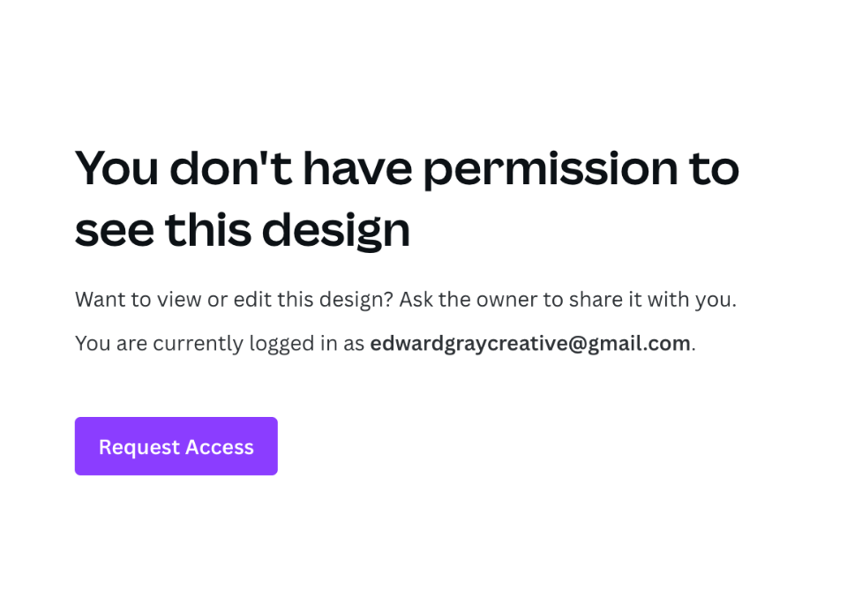

*Figure 1 Example of the access request button*

Please email the Brand Team to highlight the access request, so we can give you permission as soon as possible. The Brand Team will then be prompted to grant access to the new user.

## 2. Using templates

Once approved, you will now have access to use and edit this template.

It is vital you **DO NOT EDIT** brand templates as this will make changes for all users.

You must press **USE THIS TEMPLATE** or **USE THIS TEMPLATE FOR NEW DESIGN.**

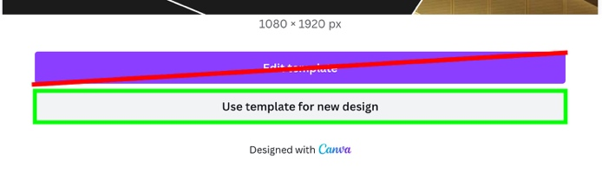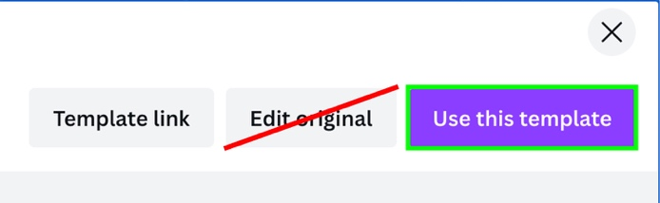

*Figure 2 Highlighting the correct link to ensure the main template is not amended*

If it doesn’t give you this option, then you must create a copy through the file navigation:

*Figure 3 Showcasing how to save the file so you don’t save over the template*

It’s **essential** you check you are using a copy of the template before starting any work. If you are unsure, please contact the Brand Team: [**brand@contacts.bham.ac.uk**](mailto:brand@contacts.bham.ac.uk)

## 2. Training

We recently held a [Canva training session](https://bham.sharepoint.com/sites/BrandAmbassadorNetwork-Network/_layouts/15/guestaccess.aspx?share=Eec-IAinwXtHt_gm1PyUnS4B2dDNkdptjycfdaVAhS_12w&e=ivvg7W), which we recommend you watch to bring yourself up-to-speed on the guidance before you begin using the templates.

## 3. Top tips

1) Check the logo is correct: <https://brand.birmingham.ac.uk/essentials/#B103_Our-logo>

2) Check your lines of intent adhere to the guidelines: <https://brand.birmingham.ac.uk/essentials/#B103_Our-logo>

3) Ensure your text is as concise as possible and in line with our Tone of Voice. Do not add additional text blocks outside of those provided on the templates: <https://brand.birmingham.ac.uk/essentials/#B192_Tone-of-voice>

4) Do not use templates incorrectly – eg. poster templates on social media, or re-size templates for other collateral.

5) Make sure your image is on-brand, not stretched or distorted. Do not create designs with additional images in the spaces – use the template spaces provided. If your image doesn’t work on that template, try a different template: <https://brand.birmingham.ac.uk/essentials/#B195_Photography>

6) Do not change the fonts; these are designed to be Times New Roman and Arial as outlined in our guidelines: <https://brand.birmingham.ac.uk/essentials/#B173_Typography>

7) Double check the ‘We activate’ sign off. The template currently has three dots for an activation message; make sure you complete this: <https://brand.birmingham.ac.uk/essentials/#B186_We-activate-sign-off>

8) Check the design with your Brand Ambassador before going live, or printing. You can find the list of Ambassadors here: <https://brand.birmingham.ac.uk/wp-content/uploads/2023/09/Brand-Ambassador-Network-Sept_2023-NEW.xlsx>

## 3. Printing

As discussed in the training, these posters and templates have been designed as low-level, self-serve, mainly digital collateral. However, we do appreciate there will be occasions where elements will need to be printed (event signage, non-campaign posters etc).

If you are printing from the templates and do not have Canva Pro, you can print a RGB PDF, but this is only suitable for digital office printers.

If you do want to have this printed professionally (in CMYK, with crops) with Creative Media or any other external printers, please be aware this is likely to incur an additional charge for set up.

## 4. Available templates

The following templates are available on the University Brand Canva account. To gain access to the templates, please contact the University Brand Team [brand@contacts.bham.ac.uk](mailto:brand@contacts.bham.ac.uk)

### Poster Templates

Available on request:

Landscape Posters, A4 & A3

Portrait Posters, A4 & A3

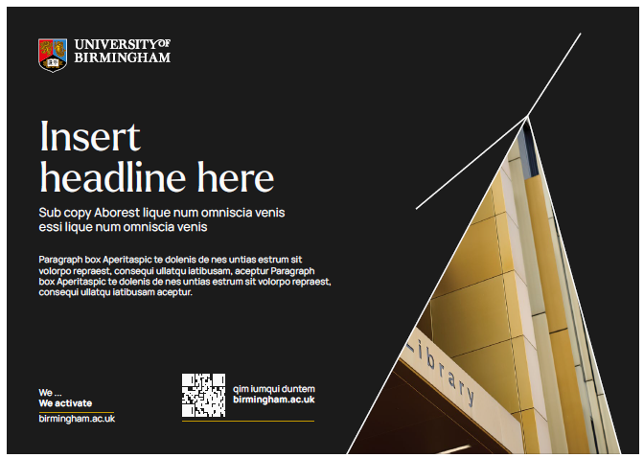

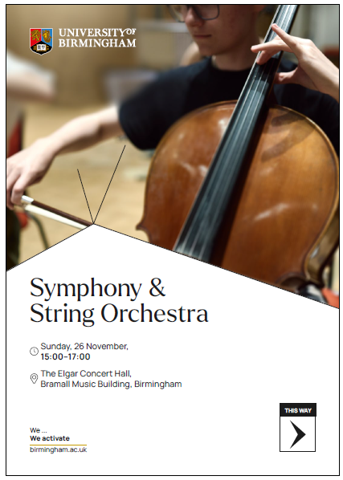

*Figure 4 Event signage options*

### Digital Screens Templates

Available on request:

1080x1920

1280x720

1230x465

1920x1080

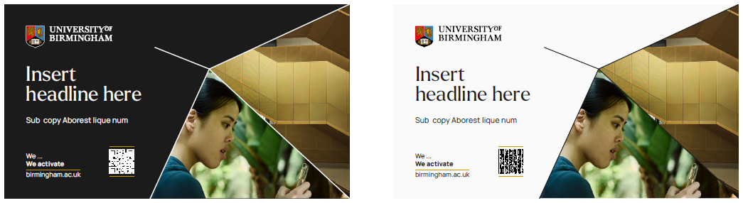

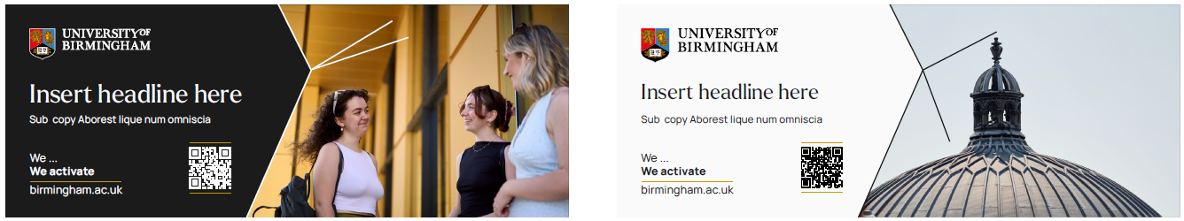

*Figure 5 Digital screen template examples*

### Totem Templates

Available on request:

1089 x 1285

1080 x 1920

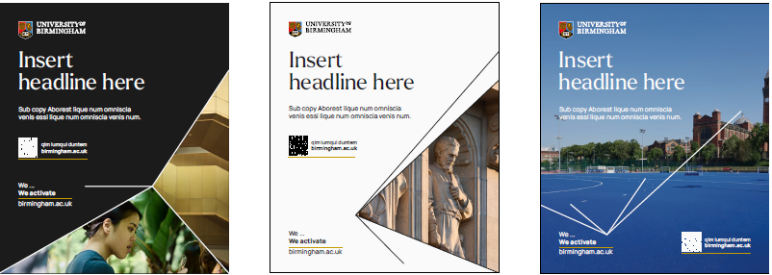

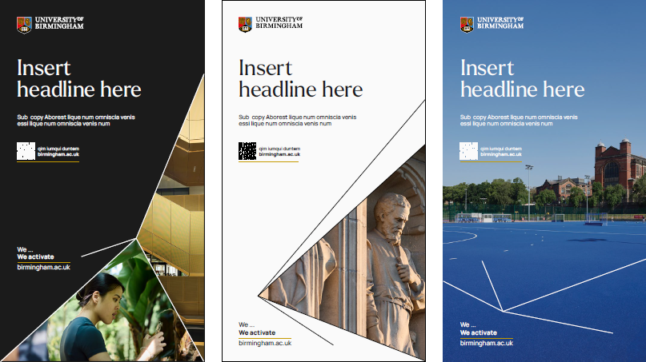

*Figure 6 Totem template examples*

### Email Newsletter Templates

Available on request:

600 x 300

600 x 350

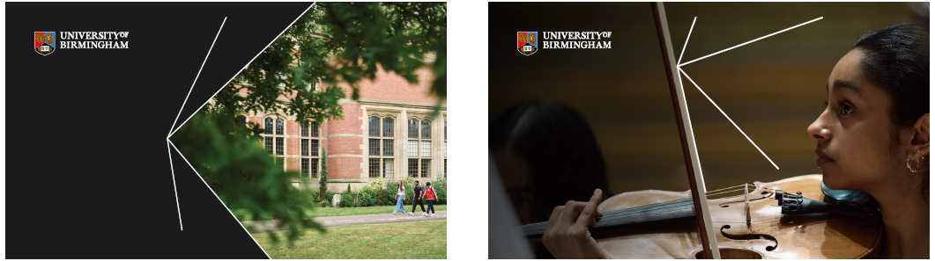



*Figure 7 Email newsletter template examples*

### Social Media Templates

Available on request:

Cover photos, LinkedIn, Facebook & Twitter

Paid & Organic, simple & with imagery

1:1

4:5

9:16

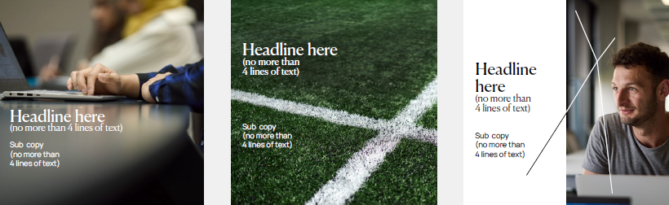

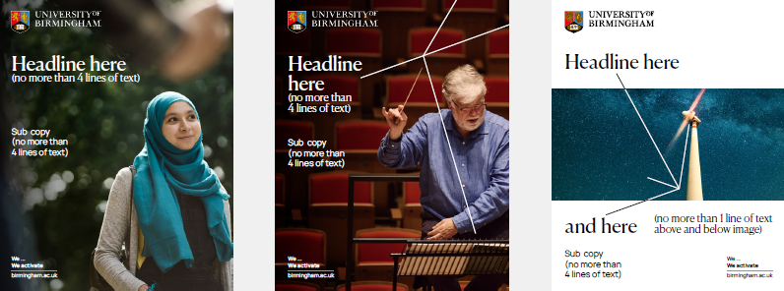

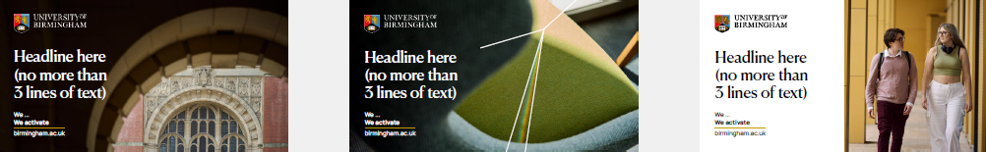

*Figure 8 Social Media template examples*