Business cards ordering process

To order your University of Birmingham business cards, please follow these steps:

Email Ashley Miranda in Creative Media – [a.n.miranda@bham.ac.uk](mailto:a.n.miranda@bham.ac.uk) with the amount of business cards needed.

You shall receive an estimate for your business cards within 2 working days. Once you have raised the PO and sent to Ashley, you’ll then be sent a business card briefing form to populate the information needed for your order.

From this point it will take up to 10 working days from order receipt to delivery.

## Examples of main business card

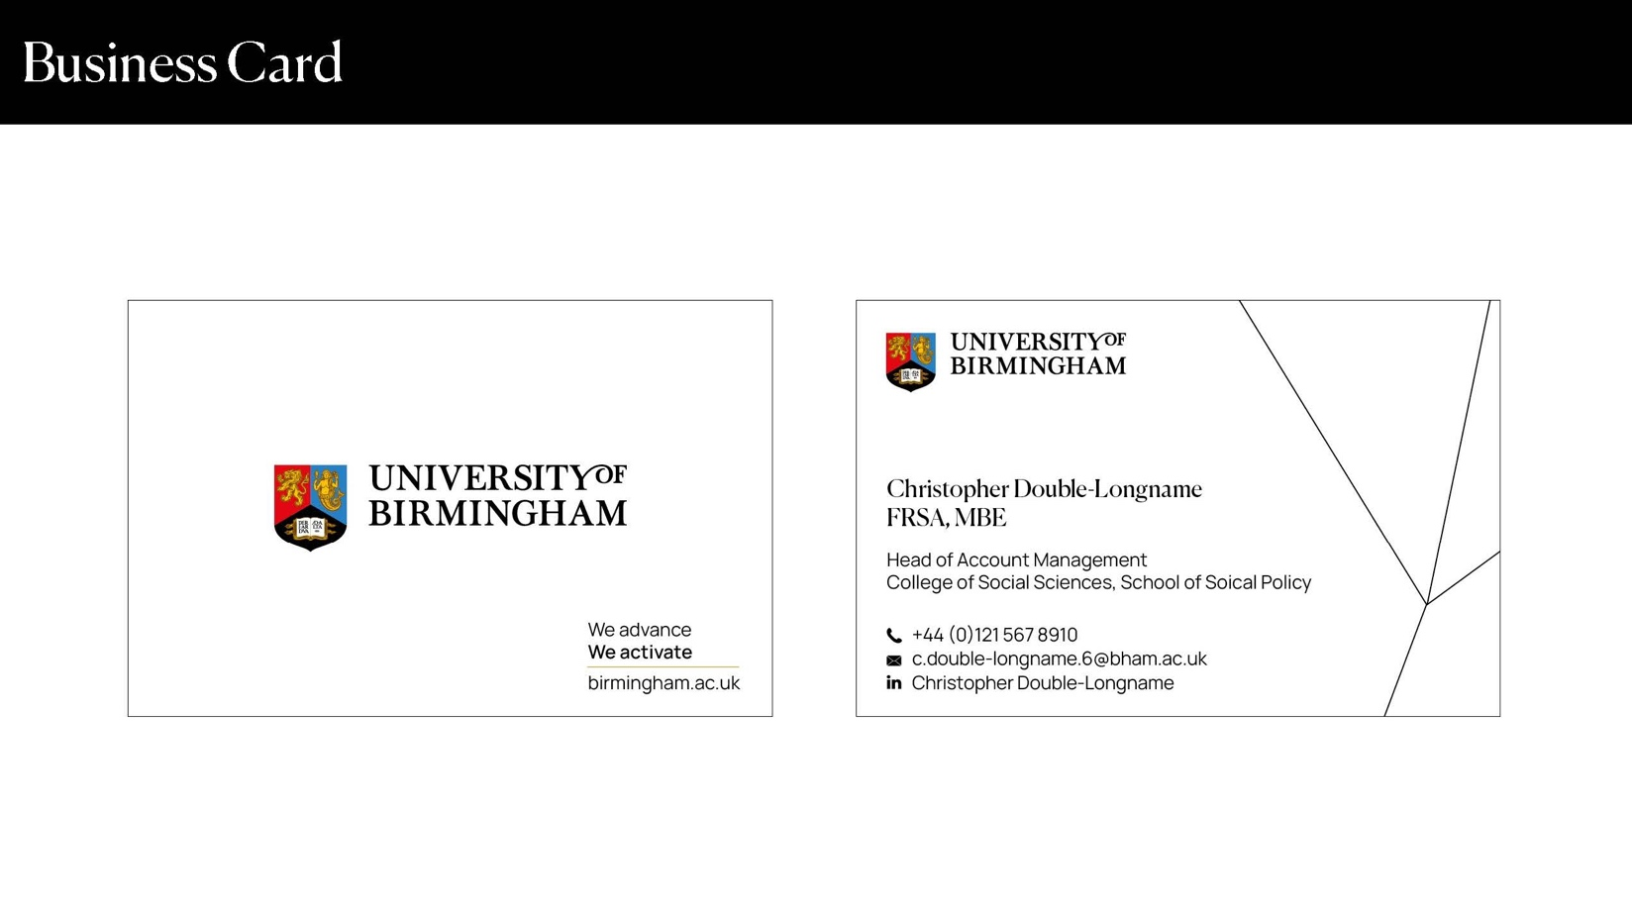

## Example of dual language card

